**ASSIGNMENT 2**

**DOMAIN:** IOT – Internet of Things.

ARAVIND G - 211419106030

**Question:**

To build a python program, to get random temperature & humidity values and write a condition to alarm continuously in case of high values.

**Python Code:**

**import time**

**import random**

**i=0**

**while(i<=2000):**

**i=i+1**

**time.sleep(5)**

**temp=random.randint(0,30)**

**humid=random.randint(1,100)**

**if temp<=15:**

**print(temp,"the temperature is low")**

**elif temp<=25:**

**print(temp,"the temperature is normal")**

**else:**

**print(temp,"the temperature is high")**

**if humid<=15:**

**print(humid,"the humidity is low")**

**elif humid<=80:**

**print(humid,"the humidity is normal")**

**else:**

**print(humid,"the humidity is high")**

**Screenshot Of Code:**

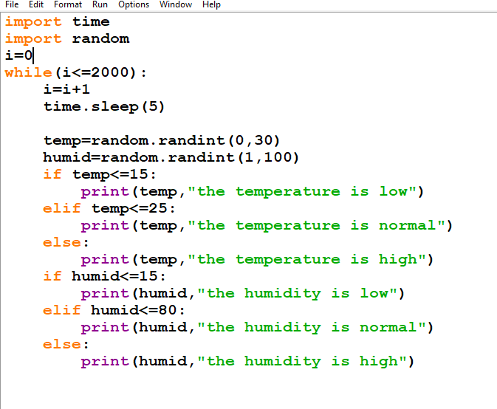

**Output Of Code:**

